More than 2 years back, I wrote an [article](https://ksmphanindra.wordpress.com/2015/04/14/sadhguru-and-rishi-prabhakar-a-curious-connection/) on Sadhguru’s connection with Guruji Rishi Prabhakar. In that article, I concluded with reasonable certainty that “Sadhguru was involved with Rishi Prabhakar’s SSY, possibly as a teacher”. My only source then was a trusted eye-witness who told me that he participated in a class conducted by Sadhguru for Rishi Prabhakar in Hyderabad. Since writing that article, my confidence in this possibility grew, mainly because there were several comments on my blog-post claiming the same. So in my recent [article](https://ksmphanindra.wordpress.com/2017/11/02/the-controversial-death-of-sadhgurus-wife-vijji/)on Vijji’s death, I wrote that  “I am pretty sure about Sadhguru’s involvement with SSY as a teacher”.

Of course, this feeling is subjective and personal. Other people can question my source. Online comments are not trust-worthy either. So we need a more solid proof. After all, my article is not the first article to explore Sadhguru’s past. Many online articles and forums discussed Sadhguru’s connection with Rishi Prabhakar before me. These articles (including mine) only seem to convince skeptics, but not Sadhguru’s devotees. From a Sadhguru’s devotee’s perspective, these are all baseless allegations; efforts to defame Sadhguru. This feeling is understandable. It is also valid. The onus of proof always rests on the person who makes the claim.

So finally, here is a proof. This is a photo of Sadhguru with Rishi Prabhakar. Rishi Prabhakar is the man with the beard at the center of this picture. Sadhguru is to his left but it is difficult to recognize Sadhguru in the first look! He looks very different then, with a clean shave and a thick black mustache!

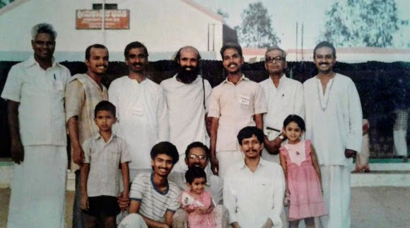Sadhguru with Rishi Prabhakar (Source: An anonymous person who wants to bring out the truth!)

But Isha devotees would easily recognize Sadhguru in the picture above. Isha Foundation and Isha volunteers put several photos of Sadhguru when he was still Jaggi Vasudev. For example, check the below photo of Sadhguru with his wife Vijji and you will instantly recognize that the man in the pic above is also Sadhguru!

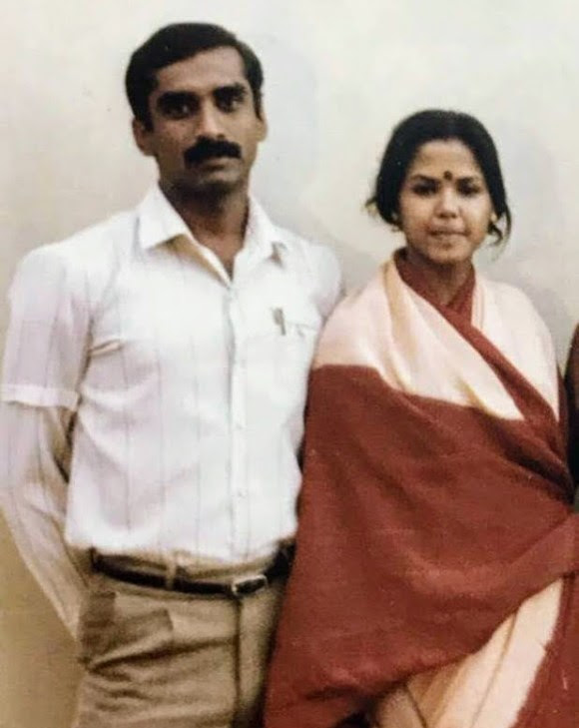Old photo of Sadhguru with his wife Vijji (Source: <https://www.facebook.com/photo.php?fbid=698619923679472&set=a.123624867845650.1073741827.100005944116564&type=3&theater>)

So what does this prove? Clearly Sadhguru was close to Rishi Prabhakar as can be judged from the group photograph. Also the name tag on him indicates that this picture was taken during a course (my anonymous source says that this picture was taken during Rishi Prabhakar’s first teacher training program and Sadhguru was in that batch). At the minimum, this picture proves that Sadhguru was involved with Rishi Prabhakar and the fact is that he does not speak about it now. Not even a mention!

It is said that Sadhguru had some differences with Rishi Prabhakar and thus split from him. Earlier, he was indeed working for Rishi Prabhakar in Coimbatore per the confession of an ex-Isha inmate  –

Long ago as a young boy, my friend convinced me to attend Sahaja Sthithi yoga (SSY) which was being conducted by Ms. Pankaj and Mr. Jaggi Vasudev. The program was conducted in two different venues in Coimbatore at the same time. I went to Jaggi’s class because it was closer to my house.

At the same time, two other SSY teachers Mr. Vinay and Mr. Dutta were teaching the same program in Salem , Trichi, Bengalore etc. I volunteered in all the four people programs, including the Bhava Spandana Programs (BSP). **All the four teachers including Jaggi, along with many others, were trained under Rishi Prabhakar, and were teaching the same programs (SSY,BSP and advanced meditation programs) all designed by Rishi Prabhakar.**

Very soon, Jaggi eyeing the potential for growth, separated himself from Rishi Prabhakar’s group, started Isha Foundation and recreated himself under his self given name Sadhguru. **And he claimed the SSY and BSP as his own creation**. The same program content of Rishi Prabhakar is today printed in Jaggi’s so-called bestselling book the “Inner Engineering for wellbeing” with some changes.

(I am not pasting the entire confession of this ex-Isha inmate as it may be too disturbing for Isha followers. But even if we ignore this guy, there are many others who claim the same. Given the proof of the photo and these multiple claims, I think we can no longer brush away Sadhguru’s connection with Rishi Prabhakar as a mere fiction)

Of course, the photo does not prove any of these claims. But when Sadhguru loves to speak about his past and goes on to explain such irrelevant details as to how he embarrassed his school teacher by commenting on the color of her under-wear (Source: Arundhati Subramanian’s book on Sadhguru), he should at least have the courtesy to mention Rishi Prabhakar Ji’s name and credit him for any of the spiritual knowledge he got from him. But even after Rishi Prabhakar’s death in 2014, when many Gurus came down and offered their pranams to Rishi Prabhakar for everything they received from him, there is no public message from Sadhguru.

The anonymous person who provided the photo was not bitter about Sadhguru. He actually gave Sadhguru a benefit of doubt. He said that Sadhguru might have his version of truth and we should allow him to say it and listen to it before making any conclusions. I completely agree. But will Sadhguru ever speak up on this topic? It would be great if any of the Isha devotees can ask him and get his version. Truth about this matter should come out, however hard it may be to digest for some people. Though it may hurt at first, ultimately Truth leads to goodness. May Truth prevail!